[Programme Title]
Integrated Impact Assessment
September 2022
[Programme Lead Name]
Contents
Document and Version Control 4
1. What is an Integrated Impact Assessment? 5
Our Legal and Moral Duties and Obligations 5
2. [Programme/Policy Title] Executive Summary 7
Key Headlines and Conclusions 7
Potential Positive Impacts 7
Potential Negative Impacts 7
Supporting Data and Engagement 7
Conclusions and Recommendations 7
3. Programme Introduction 8
Case for Change 8
Baseline Report Feedback 8
Engagement Methodology 8
4. Affected Populations and Environments 9
4.1 Protected Characteristic Groups 9
Age 9
Disability 9
Gender Reassignment 9
Marriage and Civil Partnership 9
Pregnancy and Maternity 9
Race 9
Religion or Belief 9
Gender 9
Sexual Orientation 10
4.2 Vulnerable Communities and Groups 11
Economically deprived communities 11
Socially Excluded Groups 11
Carers 11
4.3 Patient, Client and Staff Experience 12
Quality of Care & Clinical Effectiveness 12
Patient Safety 12
Workforce Retention and Recruitment 12
4.4 Climate Change and our Environment 13
Fuel and Energy Consumption 13
Facilities and Estates 13
Pollution 13
Carbon Offsetting 13
4.5 Health Inequalities 14
Rural Communities 14
Seldom Heard Groups 14
Mental Health and Wellbeing 14
4.6 Travel and Access Impact 15
Independent Transportation 16
Public Transportation 16
Travelling on Foot 16
Transfer Times 16
5. Conclusions and Recommendations 17
Significant Positive Impacts 17
Significant Negative Impacts 17
Mitigation and Enhancements 17
Future Activity and Engagement 17

For guidance and support in completing this document or an overview of the process, please visit our webpage at the link below:

https://www.shropshiretelfordandwrekin.ics.nhs.uk/full-integrated-impact-assessment/

Document and Version Control

Author
Version |  | 001
Document Status (Draft/Final)
Description and purpose
Version history:
Date | Version | Author | Summary of changes / notes
Distribution
Date | Version | Group / Board / Manager | Notes / Comments
Approvals
Date | Version | Group / Board / Manager | Notes / Comments

What is an Integrated Impact Assessment?

Shropshire, Telford and Wrekin Integrated Care System has developed an Integrated Impact Assessment (IIA) process, forming a core part of the service and policy development process for our Integrated Care System (ICS). An IIA enables system partners to fully assess the positive and negative impacts of new services or service changes, policies and functions, on their local population and communities.

This is achieved through the identification of potential positive and negative impacts that may affect
- the nine protected characteristic groups,¹
- our climate change responsibilities,
- health inequalities,
- Socially excluded communities/carers & economically deprived groups,
- our staff

An IIA also offers mitigating actions and potential solutions to these challenges, founded in data insight and primary research.

The IIA process has three core stages, an initial screener tool, a Baseline Equality Report, and a full Integrated Impact Assessment. Upon completion, the programme/project will have fulfilled its statutory requirements regarding equality.

Previously, a statutory body may have carried out multiple assessments when reviewing options to make changes to a service. An IIA is a holistic framework which ensures that new policies and programmes have been considered through not only an equality lens, but also economic, environmental and health inequalities.

An integrated impact assessment is a tool that identifies impacts, both positive and negative.

Our Legal and Moral Duties and Obligations

The NHS Constitution states that the NHS has a duty to “…pay particular attention to groups or sections of society where improvements in health and life expectancy are not keeping pace with the rest of the population”. This is reflected in the Health and Social Care Act 2012, which introduced legal duties to reduce health inequalities, with specific duties on Clinical Commissioning Groups (CCGs) and NHS England. The Health and Care Act 2022 subsequently transposes the duties previously held by CCGs directly onto Integrated Commissioning Boards (ICBs).

ICBs have duties to:
- Have regard to the need to reduce inequalities between patients in access to health services and the outcomes achieved;
- Exercise their functions with a view to securing that health services are provided in an integrated way, and are integrated with health-related and social care services, where they consider that this would improve quality, reduce inequalities in access to those services or reduce inequalities in the outcomes achieved;
- Include in an annual commissioning plan an explanation of how they propose to discharge their duty to have regard to the need to reduce inequalities; and
- Include in an annual report an assessment of how effectively they discharged their duty to have regard to the need to reduce inequalities.

Similarly, local authorities in England carry legal responsibilities to meet equality and diversity standards. Many of these are incorporated into the Equality Framework for Local Government 2021, which seeks to “help organisations, in discussion with local partners including local people, review and improve their performance for people with characteristics protected by the Equality Act 2010”.

Health inequalities must be properly and seriously taken into account by public sector bodies, including all NHS organisations and both local authorities within the STW ICS. The NHS Long Term plan aligns the duties and responsibilities of the partner organisations behind the vision that increased collaborative working within health, care services, public health and the voluntary sector is fundamental in tackling equality and health inequality challenges.

[Programme/Policy Title] Executive Summary

Key Headlines and Conclusions
- To be completed at the conclusion of this piece of work – brief summary of approach, findings and recommendations.
- What are the 4/5 key findings that can be drawn out of this IIA?

Potential Positive Impacts
- Does this piece of work address pre-existing health inequalities, or seek to take targeted action to improve outcomes for protected groups?
- What are the key positive outcomes that this programme of work seeks to deliver, to benefit the patient?

Potential Negative Impacts
- Having completed this assessment, what are the key negative impacts identified through this process?

Supporting Data and Engagement
- What are the key data tables and fields that support the findings above?
  - This can include publicly available census or ONS data, clinical data, or other relevant data sources
- Were these findings identified through an engagement process? What have our populations told us?

Conclusions and Recommendations
- What are the 4/5 key findings that can be drawn out of this IIA? What mitigations have been identified to address negative impacts that have been identified?
- What are the proposed next steps for the programme of work?

Programme Introduction

Case for Change
- Summarise the business case for change (include document link)
- Why does the service need to change?
- Does this align with national programmes, or is it West Midlands/STW specific

Baseline Report Feedback
- What were the outputs from the Baseline Report? What key data sources informed these findings, and what impacts have been identified?

Engagement Methodology
- Outline your methodology for engaging with the populations and communities of Shropshire, Telford and Wrekin and Powys at a system, place and neighbourhood level to enable affected people and groups to have their say on proposed changes to their services.
- Detail any work in partnership with Engagement teams from any of the ICS system partners.

Affected Populations and Environments

4.1 Protected Characteristic Groups

Age
- Assess the impact (both positive and negative) on a person belonging to a particular age (for example 32-year-olds) or range of ages (for example 18- to 30-year-olds)

Disability
- Assess the impact on individuals or groups with a disability. A person has a disability if she or he has a physical or mental impairment which has a substantial and long-term adverse effect on that person's ability to carry out normal day-to-day activities.

Gender Reassignment
- Assess the impact on individuals or groups undergoing the process of transitioning from one sex to another.

Marriage and Civil Partnership
- Assess the impact on marriage and civil partnerships.
  - Marriage is a union between a man and a woman or between a same-sex couple.
  - Same-sex couples can also have their relationships legally recognised as 'civil partnerships'. Civil partners must not be treated less favourably than married couples (except where permitted by the Equality Act).

Pregnancy and Maternity
- Assess the impact on women who are pregnant or in the maternity period.
- Pregnancy is the condition of being pregnant or expecting a baby. Maternity refers to the period after the birth, and is linked to maternity leave in the employment context. In the non-work context, protection against maternity discrimination is for 26 weeks after giving birth, and this includes treating a woman unfavourably because she is breastfeeding.

Race
- Assess the impact on individuals or groups on the grounds of race. Race refers to a group of people defined by their race, colour, and nationality (including citizenship) ethnic or national origins.

Religion or Belief
- Assess the impact on an individual of group’s religion or beliefs. Religion refers to any religion, including a lack of religion. Belief refers to any religious or philosophical belief and includes a lack of belief. Generally, a belief should affect your life choices or the way you live for it to be included in the definition.

Gender
- Assess the impact on an individual or group’s sex.

Sexual Orientation
- Assess the impact on an individual or group’s sexual orientation. Sexual orientation refers to whether a person has sexual attraction is towards their own sex, the opposite sex or to both sexes.

4.2 Vulnerable Communities and Groups

Economically deprived communities
- Assess the impacts, both positive and negative) on local deprivation domains such as income, employment, education/skills/training, health and disability, barriers to housing and services, living environment and crime.
- Assess this impact at both a place level (e.g. between an individual street or cul-de-sac and an LSOA), neighbourhood (e.g. between an LSOA and a local authority area), and at a system level.

Socially Excluded Groups
- Assess the impact (both positive and negative) on socially excluded groups. Socially excluded groups can include people who experience homelessness, drug and alcohol dependence, vulnerable migrants, Gypsy, Roma and Traveller communities, sex workers, people in contact with the justice system and victims of modern slavery.

Carers
- Assess the impact (both positive and negative) on the health and wellbeing of carers, both voluntary and renumerated.

4.3 Patient, Client and Staff Experience

Quality of Care & Clinical Effectiveness
- Assess to what extent the proposal will sustainably improve the clinical effectiveness of care provided to the affected population
  - e.g. Evidence-based practice used, clinical leadership/engagement, reduction in variation/improved consistency in care, metrics to measure success, ability to follow current guidelines, promotion self-care for long term conditions, alignment with similar and/or complementary transformation programmes of work.

Patient Safety
- Assess the impact (both positive and negative) on the level of safety in the clinical care activity provided to the affected population
  - e.g. Avoidable harm/incidents, HCAI rates, safeguarding incidents, ability to follow guidance from professional bodies

Workforce Retention and Recruitment
- Assess the impact (both positive and negative) on workforce retention and recruitment by partner organisations with the ICS.
- How does the aims and objectives of the proposals align with national and regional human resource aims and objectives. E.g. The NHS National Retention programme

4.4 Climate Change and our Environment

Fuel and Energy Consumption
- Assess to what extent the changes will result in an increase or decrease in the quantity and length of journeys made, and the subsequent impact on fuel or energy consumption.

Facilities and Estates
- Assess the impact (both positive and negative) on facilities and estates owned by the STW ICS constituents or partner organisations.
- Assess the impact on our neighbouring properties, and compliance with local authority planning regulations e.g. increase in activity during unsociable hours.

Pollution
- Assess to what extent increased or decreased road travel will affect noise and air pollution in the local area.

Carbon Offsetting
- Assess a methodology to identify the potential release of carbon dioxide through any related activity, and the actions which can be taken to offset this.
Biodiversity
- Assess to what extent any new construction will have an impact – either positive or negative – on local biodiversity in or around the site. Biodiversity refers to anything living, including animals and plants.
- Considerations can include whether development work may impact habitats for important or threatened species, or whether larger scale habitat degradation may occur.

4.5 Health Inequalities

Rural Communities
- Assess the impact (both positive and negative) on populations living in rural areas. People living in rural areas within Shropshire, Telford and Wrekin and Powys often have considerably greater travel times and costs to access health and care services, and are more likely to be elderly, with increased frailty and complex comorbidities.

Seldom Heard Groups
- The term 'seldom-heard groups' refers to people or groups who are users of health and social care services, but who are under-represented and less likely to be heard by service professionals and decision-makers. Assess the actions that can be taken to reduce health inequalities faced by these people or groups.

Mental Health and Wellbeing
- Assess the impact (both positive and negative) on populations living with a mental health condition, and the opportunities for reducing the inequalities they may face as they access the service.

4.6 Travel and Access Impact
A travel and access analysis looks at the travel implications of service reconfiguration.
It is undertaken to understand the current configuration of a service or policy, against which to model the impact of the options for future service reconfiguration. This should consider both transportation from home to site, and also after they have arrived on site.

Depending on the scope and scale of the proposed changes, particularly any changes in location, the scope of detail required in this section will differ. You need to answer the questions below and provide analysis for each potential option in your programme of work.

Significant changes will require detailed journey time analysis, including average journey times by locality, and GIS detail including mapping. External support is available for this, including from the CSU Strategy Unit.

Example mapping and detail from other programmes of work are below
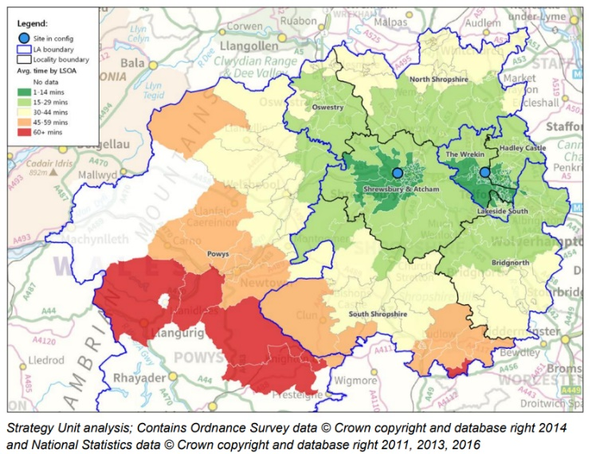

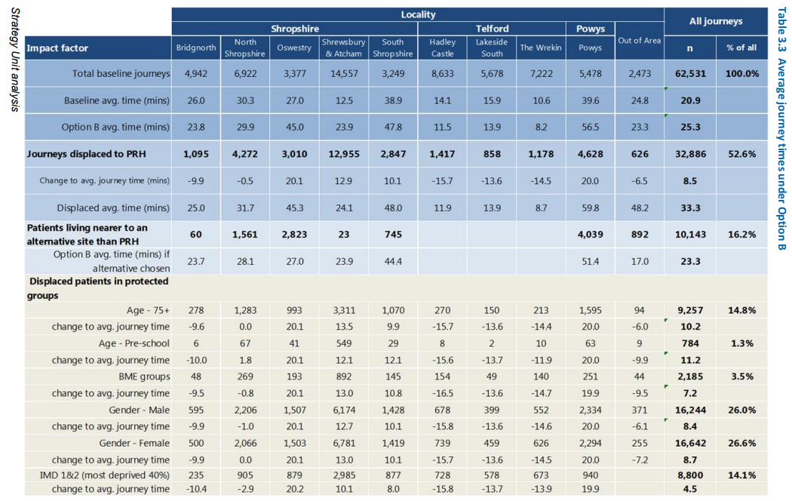

For each option:

Independent Transportation
Assess to what extent service users and staff journeys using independent transportation to access services will be positively or negatively affected by any changes in location?
- Will journey times be increased or decreased? What is the likelihood and timescale of the impact? What is the direction and scale of the impact?
- Will users incur extra financial costs as a result of any changes to the service? E.g. parking charges, toll roads, clean air zone charges
- How will this impact on any health inequalities identified previously? Are there equality groups who have a higher than average need for the service, who are at risk of being disproportionately affected.

Public Transportation
Assess to what extent service users and staff journeys using public transportation to access services will be positively or negatively affected by any changes in location?
- Will journey times be increased or decreased? What is the likelihood and timescale of the impact? What is the direction and scale of the impact?
- What impact will rurality have on the above?
- How will this impact on any health inequalities identified previously? Are there equality groups who have a higher than average need for the service, who are at risk of being disproportionately affected.
- Have future changes to public transportation routes been considered?

Travelling on Foot
Assess to what extent service users and staff journeys travelling on foot to access services will be positively or negatively affected by any changes in location?
- Will journey times be increased or decreased? What is the likelihood and timescale of the impact? What is the direction and scale of the impact?
- How will this impact on any health inequalities identified previously? Are there equality groups who have a higher than average need for the service, who are at risk of being disproportionately affected.

Transfer Times
Assess how transfer times (if applicable) to emergency care and/or other related services will be positively or negatively affected by any changes in location?
- Will journey times be increased or decreased? What is the likelihood and timescale of the impact? What is the direction and scale of the impact?
- Would this increase any risk factors for populations living in any locality?

Conclusions and Recommendations
- Considering all of the above evidence and findings, along with any primary engagement activity carried out in support of this, use this section to clear identify key conclusions or findings and mitigations.

Significant Positive Impacts
- Without additional mitigation built into the service/policy design changes, identify:
  - Who faces a positive impact
  - What that positive impact will be
  - What this impact will look like statistically (e.g 20% decrease in average journey times for x protected characteristic group)

Significant Negative Impacts
- Without additional mitigation built into the service/policy design changes, identify:
  - Who faces a negative impact
  - What that negative impact will be
  - What this impact will look like statistically (e.g 15% increase in admissions from x protected characteristic group)

Mitigation and Enhancements
- Identify actions and deliverables to address the significant negative impacts mentioned above
- Assess and identify further opportunities to address broader health inequalities impacting populations who access the service or policy undergoing change.
- Identify opportunities to enhance positive impacts and outcomes

Future Activity and Engagement
- Outline your plans for any future engagement and involvement activity in support of this programme of work
- Monitoring processes

