[Programme Title] Baseline Equality Analysis
[Date]
[Programme Lead Name]

Document Control
Author
Version |  | 001
Document Status (Draft/Final)
Description and purpose
Version history:
Date | Version | Author | Summary of changes / notes
Distribution
Date | Version | Group / Board / Manager | Notes / Comments
Approvals
Date | Version | Group / Board / Manager | Notes / Comments

Table of contents

1.0 Programme Overview 2
1.1 Case for Change 2
1.2 Proposed Changes 2
2.0 Programme/Policy Impact 2
3.0 Shropshire and Telford & Wrekin Population Profile 3
3.1 Age and Gender 3
3.2 Components of population change and density 4
3.3 Ethnicity 5
3.4 Deprivation 7
4.0 Engagement Methodology 14
5.0 Findings 14
5.1 Impact Table 15
5.2 Impacts Mitigation Table 16
6.0 Summary and Conclusion 17
7.0 Recommendations and next steps 17
8.0 Appendix and Supporting Documentation 18

For guidance and support in completing this document, please visit our webpage at the link below

https://www.shropshiretelfordandwrekin.ics.nhs.uk/baseline-equality-analysis/

Programme Overview

Red text to be populated by programme lead:
- Brief description of the work area / function / project
  - Where is it provided in STW
  - How many people access it
- Set the scene and the objectives and aims of the project / policy
- State which organisations are delivering this work (commissioners and providers) and who has the authority to make changes to the work / service / function / policy
- Outline at what stages the EIA will be reviewed and updated throughout the process

1.1 Case for Change
- Summarise the business case for change (include document link)
- Why does the service need to change?
- Does this align with national programmes, or is it WM/STW specific?

1.2 Proposed Changes
- Headline summary of proposed changes

2.0 Programme/Policy Impact

- Feedback from the IIA Screener Tool (Please provide a brief overview of why completion of a Baseline Report has been required)
- Which protected characteristics have been identified as requiring further consideration.
- Why was this initial conclusion reached?

3.0 Shropshire and Telford & Wrekin Population Profile

Reviewing and interpreting available data sets is an important part of the IIA assessment framework, and forms the basis for the Baseline Report process. The data sets below have been pre-populated with primary publicly available sources of data, however where other sources of data are available, for example bespoke clinical datasets or more specific sources, then these should also be considered and included.

As the Shropshire, Telford and Wrekin ICS crosses over multiple local authority areas, with services sitting across different geographical and legislative boundaries, consideration should be given to which data sets are most relevant for this report. Many data sets are available both at a whole system level and broken down into local authority areas.

For support in identifying relevant sources of available data, or if you have any further questions, please contact the Communications and Engagement mailbox at stw.communications@nhs.net

3.1 Age and Gender

Table 1 shows the age and gender distribution within the Shropshire, Telford and Wrekin ICS area. Tables 2 and 3 break this down into our two local authority areas. There will be slight variance between the two data sets, as our overall data is from Mid-2020 ONS data, whilst the latest split data is from Mid-2018.

Shropshire, Telford and Wrekin Age and Gender Distribution - Mid-2020 ONS

Sex | ALL | MALE | FEMALE
All Ages | 506,737 | 251,214 | 255,523
0-9 | 54,521 | 28,049 | 26,472
10-19 | 57,468 | 29,033 | 28,435
20-29 | 53,378 | 27,818 | 25,560
30-39 | 59,180 | 29,896 | 29,284
40-49 | 61,298 | 30,529 | 30,769
50-59 | 75,424 | 37,682 | 37,742
60-69 | 62,966 | 30,694 | 32,272
70-79 | 53,179 | 25,330 | 27,849
80-89 | 24,208 | 10,536 | 13,672
90+ | 5,115 | 1,647 | 3,468

Shropshire Age and Gender Distribution - Mid-2018 ONS
Sex | ALL | MALE | FEMALE
All Ages | 320,274 | 158,827 | 161,447
0-9 | 31,831 | 16,453 | 15,378
10-19 | 34,537 | 17,459 | 17,078
20-29 | 31,999 | 17,075 | 14,924
30-39 | 34,291 | 17,436 | 16,855
40-49 | 39,523 | 19,651 | 19,872
50-59 | 48,918 | 24,362 | 24,556
60-69 | 42,637 | 20,740 | 21,897
70-79 | 35,911 | 17,118 | 18,793
80-89 | 16,900 | 7,405 | 9,495
90+ | 3,727 | 1,128 | 2,599

Telford and Wrekin Age and Gender Distribution - Mid-2018 ONS
Sex | ALL | MALE | FEMALE
All Ages | 177,799 | 88,364 | 89,435
0-9 | 23,286 | 11,939 | 11,347
10-19 | 21,593 | 10,843 | 10,750
20-29 | 22,355 | 11,614 | 10,741
30-39 | 23,185 | 11,358 | 11,827
40-49 | 23,226 | 11,865 | 11,361
50-59 | 24,265 | 12,044 | 12,221
60-69 | 18,845 | 9,204 | 9,641
70-79 | 14,024 | 6,619 | 7,405
80-89 | 5,961 | 2,555 | 3,406
90+ | 1,059 | 323 | 736

3.2 Components of population change and density

The table below shows changes to the population of Shropshire, Telford and Wrekin over time, including population density since 2001, data on internal and international migration, and birth/death rates. Several of these data sets are available down to a LSOA level, for more in-depth analysis at a local neighbourhood level.

Components of population change and density for Shropshire and Telford & Wrekin - ONS Mid-2020 Dataset

 | UNITED KINGDOM | Shropshire | Telford and Wrekin
Geography | Country | Unitary Authority | Unitary Authority
Births | 700,691 | 2,607 | 1,989
Deaths | 669,201 | 3,882 | 1,717
Births minus Deaths | 31,490 | -1,275 | 272
Internal Migration Inflow | No data | 13,053 | 7,585
Internal Migration Outflow | No data | 10,167 | 6,798
Internal Migration Net | 49 | 2,886 | 787
International Migration Inflow | 622,141 | 1,242 | 901
International Migration Outflow | 374,932 | 658 | 458
International Migration Net | 247,209 | 584 | 443
Other | 5,679 | 84 | -34
2020 people per sq. km | 276 | 102 | 625
2019 people per sq. km | 275 | 101 | 620
2018 people per sq. km | 274 | 100 | 612
2017 people per sq. km | 272 | 99 | 605
2016 people per sq. km | 270 | 98 | 598
2015 people per sq. km | 268 | 98 | 591
2014 people per sq. km | 266 | 97 | 585
2013 people per sq. km | 264 | 97 | 581
2012 people per sq. km | 262 | 96 | 578
2011 people per sq. km | 261 | 96 | 575
2010 people per sq. km | 259 | 95 | 571
2009 people per sq. km | 256 | 94 | 568
2008 people per sq. km | 255 | 94 | 565
2007 people per sq. km | 253 | 93 | 563
2006 people per sq. km | 251 | 92 | 560
2005 people per sq. km | 249 | 91 | 556
2004 people per sq. km | 247 | 90 | 553
2003 people per sq. km | 246 | 90 | 551
2002 people per sq. km | 245 | 89 | 549
2001 people per sq. km | 244 | 89 | 546

3.3 Ethnicity

This table presents ethnicity data from 2020, both at an overall Shropshire, Telford and Wrekin level, and broken down by local authority areas. As with the age and gender data sets, there will be slight variance between the two data sets, as our overall data is from Mid-2020 ONS data, whilst the latest split data is from Mid-2018.

Ethnic composition of Shropshire and Telford & Wrekin - NHS Digital Dataset 2020 – Total Numbers

 | SHROPSHIRE, TELFORD AND WREKIN | SHROPSHIRE | TELFORD & WREKIN
A - British | 471,005 | 270,390 | 137,705
B - Irish | 1,920 | 1,060 | 640
C - Any other White background | 42,065 | 12,545 | 25,170
D - White and Black Caribbean | 2,040 | 500 | 1,045
E - White and Black African | 1,410 | 285 | 785
F - White and Asian | 1,885 | 680 | 790
G - Any other mixed background | 2,955 | 960 | 1,255
H - Indian | 7,250 | 1,185 | 4,175
J - Pakistani | 3,905 | 295 | 3,125
K - Bangladeshi | 515 | 220 | 175
L - Any other Asian background | 3,605 | 1,030 | 1,430
M - Caribbean | 860 | 145 | 515
N - African | 4,985 | 635 | 3,015
P - Any other Black background | 1,775 | 265 | 995
R - Chinese | 2,750 | 1,270 | 795
S - Any other ethnic group | 3,465 | 1,435 | 1,390
T - Traveller | 15 | * | *
W - Arab | 30 | * | *
Unknown 3,4 | 26,980 | 25,335 | 11,400

Ethnic composition of Shropshire and Telford & Wrekin - NHS Digital Dataset 2020 – Percentages

 | SHROPSHIRE, TELFORD AND WREKIN | SHROPSHIRE | TELFORD & WREKIN
A - British | 81.3% | 85.0% | 70.8%
B - Irish | 0.3% | 0.3% | 0.3%
C - Any other White background | 7.3% | 3.9% | 12.9%
D - White and Black Caribbean | 0.4% | 0.2% | 0.5%
E - White and Black African | 0.2% | 0.1% | 0.4%
F - White and Asian | 0.3% | 0.2% | 0.4%
G - Any other mixed background | 0.5% | 0.3% | 0.6%
H - Indian | 1.3% | 0.4% | 2.1%
J - Pakistani | 0.7% | 0.1% | 1.6%
K - Bangladeshi | 0.1% | 0.1% | 0.1%
L - Any other Asian background | 0.6% | 0.3% | 0.7%
M - Caribbean | 0.1% | 0.0% | 0.3%
N - African | 0.9% | 0.2% | 1.6%
P - Any other Black background | 0.3% | 0.1% | 0.5%
R - Chinese | 0.5% | 0.4% | 0.4%
S - Any other ethnic group | 0.6% | 0.5% | 0.7%
T - Traveller | 0.003%
W - Arab | 0.005%
Unknown 3,4 | 4.7% | 8.0% | 5.9%

3.4 Deprivation

Indices of multiple deprivation (IMD) is a method of measuring relative deprivation across around 32,000 output areas across England.

The Indices provide a set of relative measures of deprivation for small across England, based on seven different domains, or facets, of deprivation: Income Deprivation, Employment Deprivation, Education, Skills and Training Deprivation, Health Deprivation and Disability, Crime, Barriers to Housing and Services, Living Environment Deprivation.

The data sets supporting this are publicly available, with the most recent data being from 2019.

How to interpret the table below
LSOA Code/Name – A unique identifier for each LSOA in England

Ward – Geographically descriptor for the area

Rank – When are 32,844 output areas are compared on the measures of deprivation, this is each output areas rank, where 1 is the most deprived area in England, and 32,444 the most affluent.

Decile – Output areas are divided into ten equal groups based on rank. For example on the table below, all areas between Brookside and Donnington are in the top 10% most deprived output areas.

IMD decile breakdown of most and least deprived LSOA’s within Shropshire and Telford & Wrekin – IMD2019

LSOA code (2011) | LSOA name (2011) | Ward | Index of Multiple Deprivation (IMD) Rank | Index of Multiple Deprivation (IMD) Decile
E01014108 | Telford and Wrekin 020C | Brookside | 346 | 1
E01014118 | Telford and Wrekin 023D | Madeley & Sutton Hill | 409 | 1
E01014198 | Telford and Wrekin 021B | Woodside | 541 | 1
E01014110 | Telford and Wrekin 020E | Brookside | 747 | 1
E01014201 | Telford and Wrekin 021E | Woodside | 832 | 1
E01014164 | Telford and Wrekin 017C | Malinslee & Dawley Bank | 951 | 1
E01014163 | Telford and Wrekin 017B | Malinslee & Dawley Bank | 980 | 1
E01014200 | Telford and Wrekin 021D | Woodside | 1,058 | 1
E01014197 | Telford and Wrekin 021A | Woodside | 1,385 | 1
E01014142 | Telford and Wrekin 009D | Hadley & Leegomery | 1,480 | 1
E01028957 | Shropshire 015D | Harlescott | 1,622 | 1
E01014124 | Telford and Wrekin 017A | Dawley & Aqueduct | 2,137 | 1
E01014113 | Telford and Wrekin 011C | College | 2,211 | 1
E01014115 | Telford and Wrekin 023A | Madeley & Sutton Hill | 2,582 | 1
E01014162 | Telford and Wrekin 022D | Madeley & Sutton Hill | 2,610 | 1
E01014165 | Telford and Wrekin 017D | Malinslee & Dawley Bank | 2,658 | 1
E01014120 | Telford and Wrekin 019B | Dawley & Aqueduct | 2,750 | 1
E01014116 | Telford and Wrekin 023B | Madeley & Sutton Hill | 2,767 | 1
E01029007 | Shropshire 038B | Ludlow East | 3,109 | 1
E01014127 | Telford and Wrekin 005C | Donnington | 3,209 | 1
E01028967 | Shropshire 018C | Monkmoor | 3,345 | 2
E01014185 | Telford and Wrekin 013A | St Georges | 3,765 | 2
E01014125 | Telford and Wrekin 005A | Donnington | 3,989 | 2
E01028906 | Shropshire 007A | Oswestry South | 4,288 | 2
E01014144 | Telford and Wrekin 012C | Haygate | 4,360 | 2
E01014193 | Telford and Wrekin 018C | The Nedge | 4,441 | 2
E01028962 | Shropshire 023C | Meole | 4,614 | 2
E01014208 | Telford and Wrekin 008D | Wrockwardine Wood & Trench | 4,839 | 2
E01014199 | Telford and Wrekin 021C | Woodside | 5,203 | 2
E01028934 | Shropshire 015B | Castlefields and Ditherington | 5,470 | 2
E01014196 | Telford and Wrekin 018F | The Nedge | 5,510 | 2
E01028873 | Shropshire 005A | Market Drayton East | 5,564 | 2
E01014151 | Telford and Wrekin 014B | Oakengates & Ketley Bank | 5,680 | 2
E01028983 | Shropshire 016D | Sundorne | 5,803 | 2
E01028908 | Shropshire 007C | Oswestry West | 6,138 | 2
E01014105 | Telford and Wrekin 011B | Arleston | 6,330 | 2
E01014140 | Telford and Wrekin 007D | Hadley & Leegomery | 6,436 | 2
E01028947 | Shropshire 021A | Abbey | 26,317 | 9
E01028985 | Shropshire 021D | Bayston Hill, Column and Sutton | 26,664 | 9
E01029001 | Shropshire 039E | Cleobury Mortimer | 26,675 | 9
E01029009 | Shropshire 038D | Ludlow North | 27,065 | 9
E01028911 | Shropshire 003B | Gobowen, Selattyn and Weston Rhyn | 27,074 | 9
E01028837 | Shropshire 031D | Bridgnorth West and Tasley | 27,400 | 9
E01014134 | Telford and Wrekin 012B | Ercall | 27,424 | 9
E01028966 | Shropshire 018B | Monkmoor | 27,472 | 9
E01028865 | Shropshire 004B | Ellesmere Urban | 27,676 | 9
E01028932 | Shropshire 016A | Battlefield | 27,913 | 9
E01014170 | Telford and Wrekin 004D | Muxton | 28,054 | 9
E01028860 | Shropshire 010A | Ruyton and Baschurch | 28,308 | 9
E01028929 | Shropshire 014A | Bagley | 28,438 | 9
E01028986 | Shropshire 022D | Bayston Hill, Column and Sutton | 28,849 | 9
E01028855 | Shropshire 025C | Shifnal South and Cosford | 29,044 | 9
E01014177 | Telford and Wrekin 003C | Newport North & West | 29,052 | 9
E01028916 | Shropshire 007D | Oswestry West | 29,177 | 9
E01028839 | Shropshire 029B | Broseley | 29,281 | 9
E01014172 | Telford and Wrekin 001B | Newport South & East | 29,473 | 9
E01028935 | Shropshire 024A | Bayston Hill, Column and Sutton | 29,508 | 9
E01014102 | Telford and Wrekin 007A | Apley Castle | 29,566 | 10
E01028952 | Shropshire 023B | Radbrook | 29,695 | 10
E01014183 | Telford and Wrekin 015C | Priorslee | 29,853 | 10
E01014190 | Telford and Wrekin 006F | Shawbirch | 30,303 | 10
E01028831 | Shropshire 031B | Bridgnorth West and Tasley | 30,563 | 10
E01014174 | Telford and Wrekin 001D | Newport North & West | 30,618 | 10
E01014168 | Telford and Wrekin 004C | Muxton | 30,689 | 10
E01028942 | Shropshire 020B | Copthorne | 30,768 | 10
E01028845 | Shropshire 027D | Albrighton | 30,803 | 10
E01028974 | Shropshire 023F | Porthill | 30,875 | 10
E01028949 | Shropshire 021C | Bayston Hill, Column and Sutton | 30,927 | 10
E01028963 | Shropshire 023D | Meole | 31,009 | 10
E01014132 | Telford and Wrekin 002C | Edgmond & Ercall Magna | 31,279 | 10
E01028972 | Shropshire 019B | Copthorne | 32,041 | 10
E01028953 | Shropshire 020E | Copthorne | 32,190 | 10
E01014182 | Telford and Wrekin 015B | Priorslee | 32,242 | 10
E01014181 | Telford and Wrekin 015A | Priorslee | 32,365 | 10
E01028964 | Shropshire 023E | Meole | 32,709 | 10

IMD decile breakdown of most and least deprived LSOA’s within Shropshire – IMD2019

LSOA code (2011) | LSOA name (2011) | Ward | Index of Multiple Deprivation (IMD) Rank | Index of Multiple Deprivation (IMD) Decile
E01028957 | Shropshire 015D | Harlescott | 1,622 | 1
E01029007 | Shropshire 038B | Ludlow East | 3,109 | 1
E01028967 | Shropshire 018C | Monkmoor | 3,345 | 2
E01028906 | Shropshire 007A | Oswestry South | 4,288 | 2
E01028962 | Shropshire 023C | Meole | 4,614 | 2
E01028934 | Shropshire 015B | Castlefields and Ditherington | 5,470 | 2
E01028873 | Shropshire 005A | Market Drayton East | 5,564 | 2
E01028983 | Shropshire 016D | Sundorne | 5,803 | 2
E01028908 | Shropshire 007C | Oswestry West | 6,138 | 2
E01028947 | Shropshire 021A | Abbey | 26,317 | 9
E01028985 | Shropshire 021D | Bayston Hill, Column and Sutton | 26,664 | 9
E01029001 | Shropshire 039E | Cleobury Mortimer | 26,675 | 9
E01029009 | Shropshire 038D | Ludlow North | 27,065 | 9
E01028911 | Shropshire 003B | Gobowen, Selattyn and Weston Rhyn | 27,074 | 9
E01028837 | Shropshire 031D | Bridgnorth West and Tasley | 27,400 | 9
E01028966 | Shropshire 018B | Monkmoor | 27,472 | 9
E01028865 | Shropshire 004B | Ellesmere Urban | 27,676 | 9
E01028932 | Shropshire 016A | Battlefield | 27,913 | 9
E01028860 | Shropshire 010A | Ruyton and Baschurch | 28,308 | 9
E01028929 | Shropshire 014A | Bagley | 28,438 | 9
E01028986 | Shropshire 022D | Bayston Hill, Column and Sutton | 28,849 | 9
E01028855 | Shropshire 025C | Shifnal South and Cosford | 29,044 | 9
E01028916 | Shropshire 007D | Oswestry West | 29,177 | 9
E01028839 | Shropshire 029B | Broseley | 29,281 | 9
E01028935 | Shropshire 024A | Bayston Hill, Column and Sutton | 29,508 | 9
E01028952 | Shropshire 023B | Radbrook | 29,695 | 10
E01028831 | Shropshire 031B | Bridgnorth West and Tasley | 30,563 | 10
E01028942 | Shropshire 020B | Copthorne | 30,768 | 10
E01028845 | Shropshire 027D | Albrighton | 30,803 | 10
E01028974 | Shropshire 023F | Porthill | 30,875 | 10
E01028949 | Shropshire 021C | Bayston Hill, Column and Sutton | 30,927 | 10
E01028963 | Shropshire 023D | Meole | 31,009 | 10
E01028972 | Shropshire 019B | Copthorne | 32,041 | 10
E01028953 | Shropshire 020E | Copthorne | 32,190 | 10
E01028964 | Shropshire 023E | Meole | 32,709 | 10

IMD decile breakdown of most and least deprived LSOA’s within Telford and Wrekin – IMD2019
LSOA code (2011) | LSOA name (2011) | Ward | Index of Multiple Deprivation (IMD) Rank | Index of Multiple Deprivation (IMD) Decile
E01014108 | Telford and Wrekin 020C | Brookside | 346 | 1
E01014118 | Telford and Wrekin 023D | Madeley & Sutton Hill | 409 | 1
E01014198 | Telford and Wrekin 021B | Woodside | 541 | 1
E01014110 | Telford and Wrekin 020E | Brookside | 747 | 1
E01014201 | Telford and Wrekin 021E | Woodside | 832 | 1
E01014164 | Telford and Wrekin 017C | Malinslee & Dawley Bank | 951 | 1
E01014163 | Telford and Wrekin 017B | Malinslee & Dawley Bank | 980 | 1
E01014200 | Telford and Wrekin 021D | Woodside | 1,058 | 1
E01014197 | Telford and Wrekin 021A | Woodside | 1,385 | 1
E01014142 | Telford and Wrekin 009D | Hadley & Leegomery | 1,480 | 1
E01014124 | Telford and Wrekin 017A | Dawley & Aqueduct | 2,137 | 1
E01014113 | Telford and Wrekin 011C | College | 2,211 | 1
E01014115 | Telford and Wrekin 023A | Madeley & Sutton Hill | 2,582 | 1
E01014162 | Telford and Wrekin 022D | Madeley & Sutton Hill | 2,610 | 1
E01014165 | Telford and Wrekin 017D | Malinslee & Dawley Bank | 2,658 | 1
E01014120 | Telford and Wrekin 019B | Dawley & Aqueduct | 2,750 | 1
E01014116 | Telford and Wrekin 023B | Madeley & Sutton Hill | 2,767 | 1
E01014127 | Telford and Wrekin 005C | Donnington | 3,209 | 1
E01014185 | Telford and Wrekin 013A | St Georges | 3,765 | 2
E01014125 | Telford and Wrekin 005A | Donnington | 3,989 | 2
E01014144 | Telford and Wrekin 012C | Haygate | 4,360 | 2
E01014193 | Telford and Wrekin 018C | The Nedge | 4,441 | 2
E01014208 | Telford and Wrekin 008D | Wrockwardine Wood & Trench | 4,839 | 2
E01014199 | Telford and Wrekin 021C | Woodside | 5,203 | 2
E01014196 | Telford and Wrekin 018F | The Nedge | 5,510 | 2
E01014151 | Telford and Wrekin 014B | Oakengates & Ketley Bank | 5,680 | 2
E01014105 | Telford and Wrekin 011B | Arleston | 6,330 | 2
E01014140 | Telford and Wrekin 007D | Hadley & Leegomery | 6,436 | 2
E01014134 | Telford and Wrekin 012B | Ercall | 27,424 | 9
E01014170 | Telford and Wrekin 004D | Muxton | 28,054 | 9
E01014177 | Telford and Wrekin 003C | Newport North & West | 29,052 | 9
E01014172 | Telford and Wrekin 001B | Newport South & East | 29,473 | 9
E01014102 | Telford and Wrekin 007A | Apley Castle | 29,566 | 10
E01014183 | Telford and Wrekin 015C | Priorslee | 29,853 | 10
E01014190 | Telford and Wrekin 006F | Shawbirch | 30,303 | 10
E01014174 | Telford and Wrekin 001D | Newport North & West | 30,618 | 10
E01014168 | Telford and Wrekin 004C | Muxton | 30,689 | 10
E01014132 | Telford and Wrekin 002C | Edgmond & Ercall Magna | 31,279 | 10
E01014182 | Telford and Wrekin 015B | Priorslee | 32,242 | 10
E01014181 | Telford and Wrekin 015A | Priorslee | 32,365 | 10

IMD 20% most deprived LSOA’s withing Shropshire, Telford & Wrekin Mapped – IMD2019
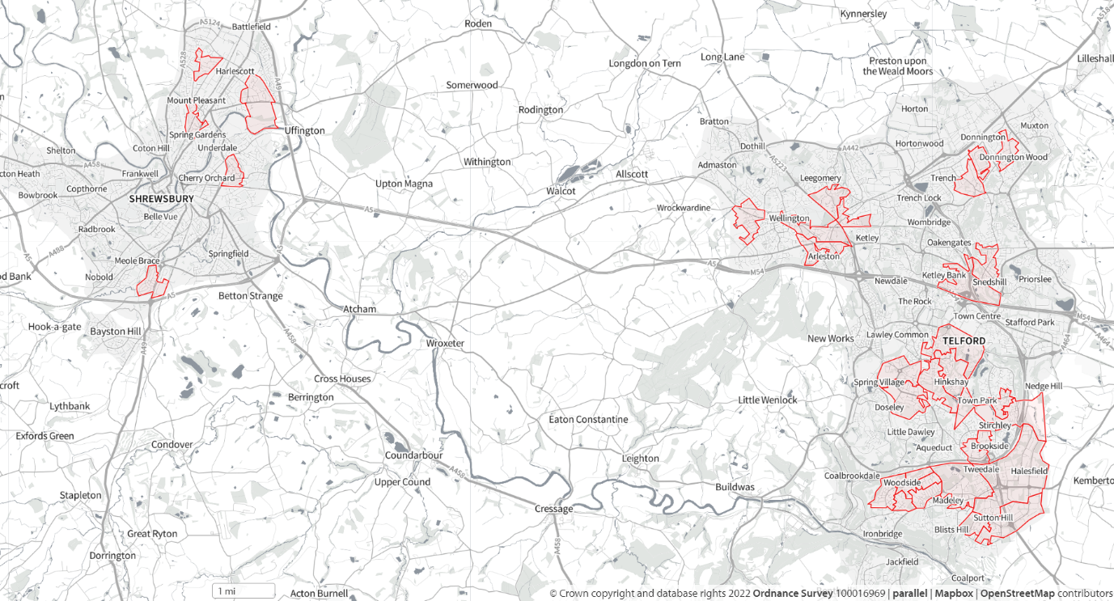

IMD 20% least deprived LSOA’s withing Shropshire, Telford & Wrekin Mapped – IMD2019
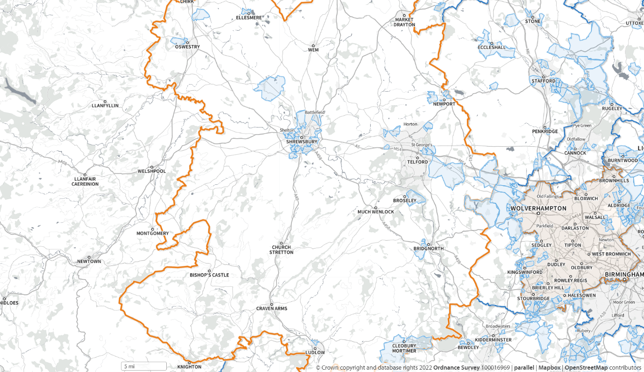

4.0 Engagement Methodology

- Explain the methods you’ve employed to engage with a proportionate number of people from equality groups (engagement plan and timelines)
- Confirm the date and time of any events and number of participants (put in appendix)
- Confirm how and what data was collected
- Specify what research / surveys/ questionnaires will be / has been undertaken
- Specify how information has been / will be evaluated, analysed and published

5.0 Findings

- Provide an overview of all the findings
  - Include quotes from participants
- Complete Impact table (Section 5.1)
  - Identify risks to characteristics from negative impacts and the benefit to equality characteristics from positive impacts
  - Clarify what has been learned in dialogue from the relevant equality characteristic and how you have verified claims of impact
- Complete Impacts mitigation table (Section 5.2), each mitigation should relate to an item in the Impact table

5.1 Impact Table

Impact No | Characteristic / Equality group | Impact Category | Positive / Negative | Impact details and rationale | Evidence
 | - Age  - Disability  - Gender reassignment (including transgender)  - Marriage and civil partnership  - Pregnancy and maternity  - Race  - Religion or belief  - Sex/Gender  - Sexual orientation  - Carers  - Socially deprived communities  - Any other | - Discrimination  - Harassment  - Victimisation  - Equality of opportunity (remove / minimise disadvantages /Meeting needs / participation)  - Good relations (prejudice / understanding)  - Disabilities  - Reduce access  - Favourable treatment  - (any others) | Positive / negative impact? | How have you become aware of the impact or potential impact?  (e.g. research, engagement event, survey)  What is the impact that has been identified?  What is the rationale behind the impact? | Is there any evidence to support or refute the claimed impact?  Provide full details. Has the impact claimed been tested with people from the relevant characteristic?

5.2 Impacts Mitigation Table

Impact No | Impact summary | Mitigation | Rationale for mitigation | Feasibility
 | Give a brief summary of the impact (from table above) | What is being suggested to mitigate for this | What is the rationale behind the suggested mitigation?  Have you consulted the characteristic(s) impacted for solutions? | Within the financial envelope, how feasible is this solution?  What are the cost implications? Can any other body help with the solution?

6.0 Summary and Conclusion
- Summarise what has been learned and how it meets the duties for the Public Sector Equality Duty (PSED)
- Provide an outline of conclusion
- Executive Summary of the risks to any of the 9 protected characteristics

7.0 Recommendations and next steps

- Outline any considerations decision makers/ policy makers should take into account
- Confirm how that feedback and analysis will be/has been fed back to decision makers/ policy makers
- Confirm what the influencing process will be and post decision how the information will influence thinking and decisions
- Outline opportunities for further engagement which should be picked up during full IIA stage

For information and advice regarding the completion of the Equalities Impact Assessment, please contact the Shropshire, Telford and Wrekin communications team on stw.communicationsteam@nhs.net

8.0 Appendix and Supporting Documentation

